605 Pre Capstone

Nathan Wyman

**Context 2**

Soft Diamond Inc. (see [SD Data.csv](https://canvas.tamu.edu/courses/357969/files/76466983?wrap=1)[Download SD Data.csv](https://canvas.tamu.edu/courses/357969/files/76466983/download?download_frd=1)) is a well reputed diamond merchant throughout the world. The firm sources diamond from various countries with different color, size, cut, depth, etc. Once the diamond pieces are sourced, Soft Diamond put the pieces for sales in various channels. Further, for some of the pieces, they also provide promotion, and they have the rough estimates of the production costs for each piece. The firm is interested to answer the following questions:

**2a.** What drives consumers to pay a higher price for a specific piece of diamond?

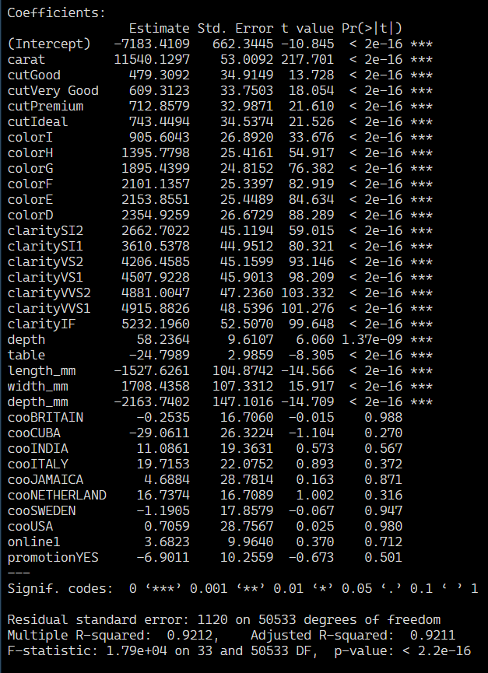

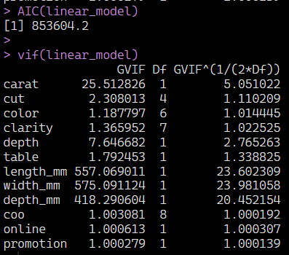

Model Performance

Price is significantly affected by Cut at all quality levels, color at all levels, all Clarity levels, depth as a percentage of total of width and length, table, length in mm, width in mm, and depth in mm.

Country of Origin, Online distribution, and Promotion have an insignificant effect on sales price.

This model has excellent R^2 and Adjust R^2 values of .9212, which means it explains 92% of the variance in the model. The variables that describe the diamonds’ dimensions- carat, length_mm, width_mm, depth_mm - covary significantly which is unsurprising. We can perform a Ridge and a Lasso Regression to handle this covariance.

Ridge and Lasso for Covariance

|  |  |  |
| --- | --- | --- |
| Lasso Estimates | Linear Regression Estimates | Ridge Estimates |
|  |  |  |
| Lasso R^2 | Linear Regression R^2 | Ridge R^2 |
|  |  |  |

The R^2 value of the Lasso model is very close to the Linear Regression model, yet it provides more significant variables. This makes our Lasso Regression model a superior, more informative model. The Ridge Regression model has several more significant country of origin levels but the R^2 is worse than the Lasso Regression. Lasso Regression should our choice of model.

After performing a Lasso Regression all of the variables that were previously significant remain so, but now several countries – Cuba, India, Italy, Jamaica, Netherlands, and Sweden have become significant. Online distribution and promotion have also become significant. It is also clear that the previously highly correlated variables referring to diamond dimensions have had their estimates shrink dramatically.

Variables that most positively affect Sales Price

A diamond with high Carat count, Ideal cut, D color classification,1F Clarity rating will command the highest price. None of these findings are surprising as these designations are the highest levels in their respective variables.

**2b.** Can a specific characteristic of a diamond have a negative impact on consumers’ willingness to pay? If a diamond has a small carat size that has the largest effect on pricing(11498/carat). Other variables that have large negative impacts in their categories are Clarity level of I1 (5201 to highest), Color rated J(2334 to highest), Cut Fair(774 to highest). Variables presented in descending order of impact on the sales price.

**2c.** Should they change geographical sourcing decisions?

Italy(17), Netherlands(15), and India(10) have positive impacts on sales price compared to Brazil, USA, and Britain(which are equivalents) and should be focused on.

While there is almost no variation in carat sizes amongst the top three countries, the Netherlands shows higher frequency in all the top three levels of both color and clarity. Soft Diamond should consider shifting production to these three countries but with a focus on the Netherlands.

**2d.** How should they plan for distribution in future? Online distribution has a positive effect on sales price whereas Promotion has a significant negative effect on sales price. Soft Diamond should focus on online sales.

It makes perfect sense that a price promotion would negatively influence the sale price because the promotion is a price reduction. Before a decision is made on whether promotion should be discontinued, Soft Diamond needs to assess whether their promotional discounts are driving sales volume at a rate that makes up for the marginal loss in sales price. If the margins are covered or exceeded by the volume of sales, then Promotions should continue.

**2e.** What is an optimal combination of carat, length (mm), width (mm), and depth (mm)?

We will have a maximum for carat, a minimum for depth, a minimum for width, and a maximum for length



NOTE:

I can’t get my carat optimality graph to be a maximum or positive and I can’t get Length to show as a maximum instead of a minimum

|  |  |  |
| --- | --- | --- |
|  |  |  |

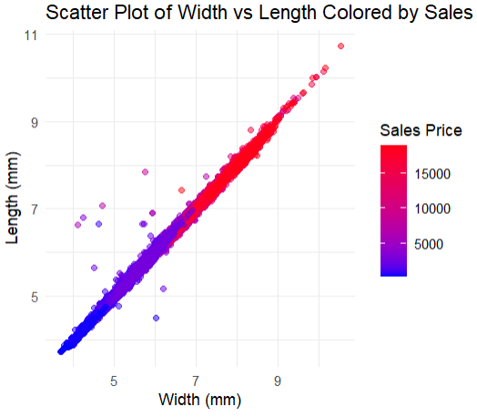

Given that most of the diamonds length and width are close to equal we can assume diamonds are typically round. We need to determine the ideal size of a round cut diamond.

According to a diamond carat calculator app([Diamond Carat Calculator (Diamond Weight)](https://www.omnicalculator.com/other/diamond-carat)) the formula for determining carat size from diamond dimensions for round cut diamonds is Diameter² × Depth × 0.0061 × (1 + GT). GT(Girdle Thickness Factor) usually lies between 1% (0.01) and 3% (0.03) for round diamonds.

Ideal Diamond Cuts have an ideal depth percentage of 59-62.6%. This percentage is determined by dividing the diamond’s height by its width.([Ideal Diamond Depth and Table by Cut | The Diamond Pro](https://www.diamonds.pro/education/diamond-depth-and-table/)).

Checking the GT range with the carat size set to the maximum carat value of 1.329481 we can test for the diameter sizes between our minimum width and maximum length that result in a depth that is above the minimum depth and within the ideal depth percentage of 59-62.6%:

**2f.** What specific strategies do you suggest such that they can increase sales?

Soft Diamond should source their diamonds from Netherlands, Italy, and India with a focus on the Netherlands as the Netherlands is the source of diamonds with higher clarity and color. They should target circular cut with the optimal sized described above when cutting their diamonds. Whenever possible diamonds with a high Carat count, Ideal cut, D color classification,1F Clarity rating should be prioritized to command the highest price. Online distribution should be focused on and grown as it is positively associated with sales price. Promotions should be further investigated to see if they are increasing volume at a level that meets or exceeds their negative impact on pricing.

APPENDIX:

Variables

They have the information on the following aspects:

1. Sales Price or consumer paid price ($)
2. Carat: Weight of the piece
3. Cut: quality of the cut (Fair, Good, Very Good, Premium, Ideal)
4. Color: diamond color, from J (worst) to D (best)
5. Clarity: a measurement of how clear the diamond is (I1 (worst), SI2, SI1, VS2, VS1, VVS2, VVS1, IF (best))
6. Length(mm): length in mm
7. Width (mm): width in mm
8. Depth (mm): depth in mm
9. Depth: total depth percentage (of width and length)
10. Table: width of top of diamond relative to widest point.
11. COO: Country from where the piece is sourced
12. Id: each piece is uniquely identified
13. Online: if the piece is online available for viewing and ordering
14. Promotion: if promotion was applied to the piece